Device Name: Razer – Blade 15 Advanced

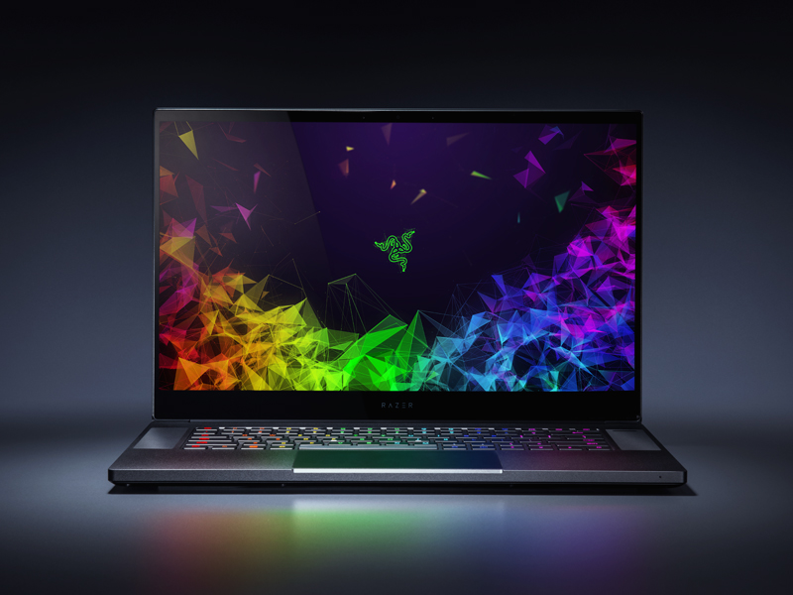

Price: $2800

**SPECIFICATIONS:**

|  |  |
| --- | --- |
| Processor: | Intel Core i7-8750H (2.2 GHz) |
| Memory: | 16 GB DDR4 |
| Storage: | 512 GB |
| Screen Size: | 15 |